**LAB 9**

**OSPF ROUTING**

**Aim:**

To aid in the comprehension and use OSPF as dynamic routing idea in computer networking for network managers or students. Instead, depending on static routing technologies, OSPF dynamic routing simulates and test real-world network scenarios in a controlled environment**.**

**Introduction:**

OSPF (Open Shortest Path First) is a popular Interior Gateway Protocol (IGP) used for routing within an autonomous system (AS) in a large enterprise or service provider network. OSPF is a link-state protocol that builds a complete topology map of the network by exchanging information about network links and their states with other OSPF routers in the network. This enables OSPF to calculate the shortest path to a destination network using the Dijkstra algorithm and to dynamically adapt to changes in the network topology.

The main advantage of a link state routing protocol like OSPF is that the complete knowledge of topology allows routers to calculate routes that satisfy particular criteria. This can be useful for traffic engineering purposes, where routes can be constrained to meet particular quality of service requirements. The main disadvantage of a link state routing protocol is that it does not scale well as more routers are added to the routing domain. Increasing the number of routers increases the size and frequency of the topology updates, and also the length of time it takes to calculate end-to-end routes. This lack of scalability means that a link state routing protocol is unsuitable for routing across the Internet at large, which is the reason why IGPs only route traffic within a single AS.

**Steps Involved for OSPF Dynamic Routing:**

**Step 1:** Set up a network with some end-devices and Switches and Routers. I have set up 2 PCs and 2 switches and 4 Routers.

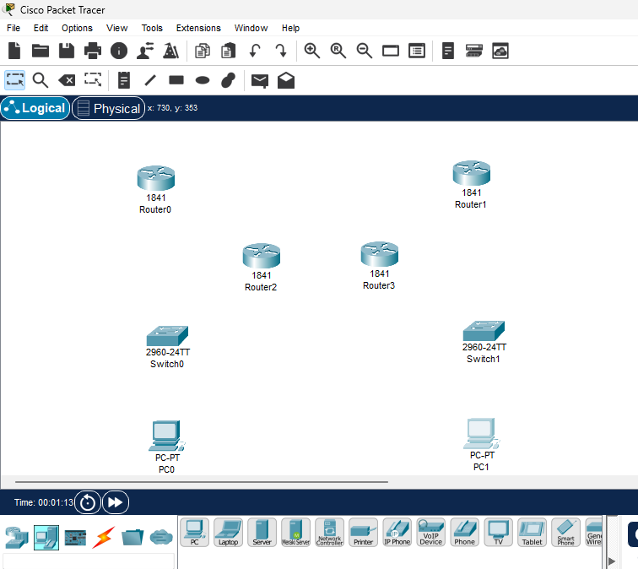

**Step 2:** Connect Devices to Each other Using Thunderbolt, copper straight- through and serial DTE.

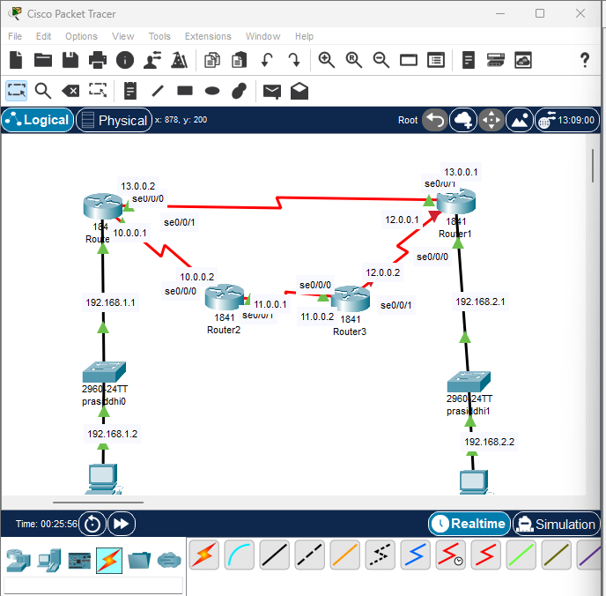

**Step 3:** .Provide IP address and Default Gateway to PC’s.

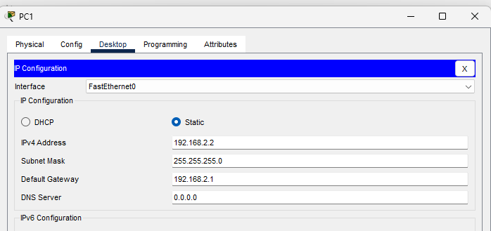

**Step 4:** Configure IP of all routers.

* Router 0 IP Configurations

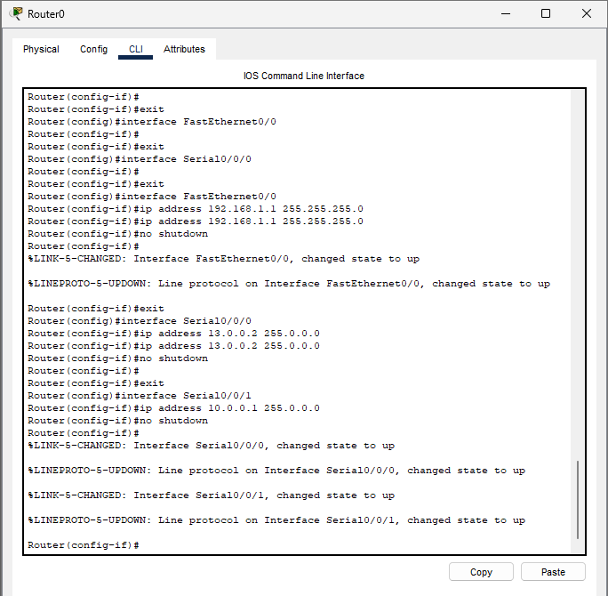

* Router 1 IP Configurations

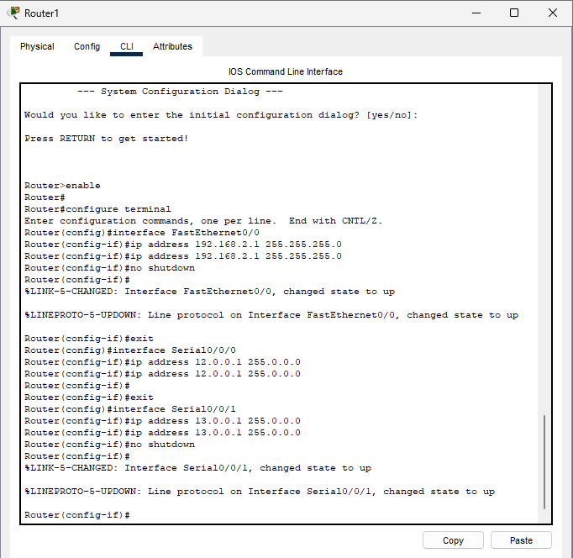

* Router 2 IP Configurations

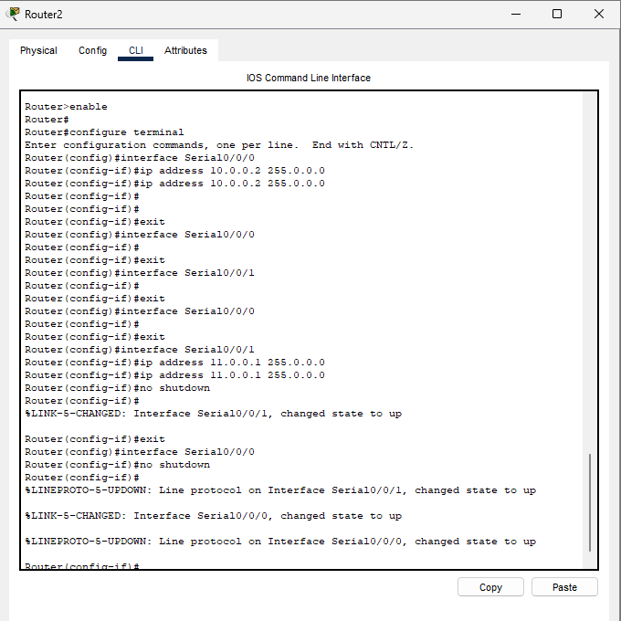

* Router 3 IP Configurations

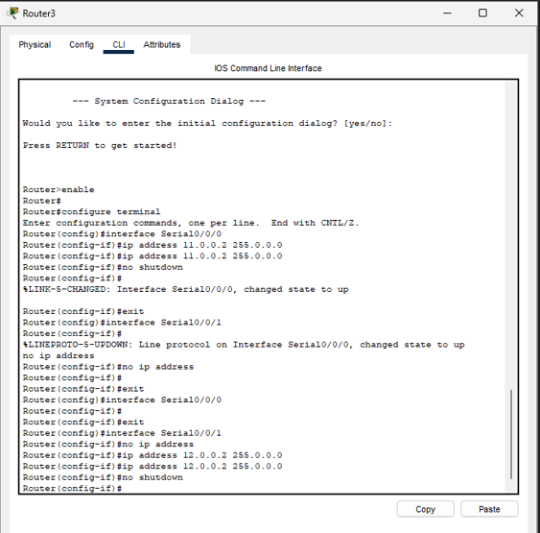

**Step 5:** Configuring the Dynamic routes.

* OSPF Route of ROUTER 0

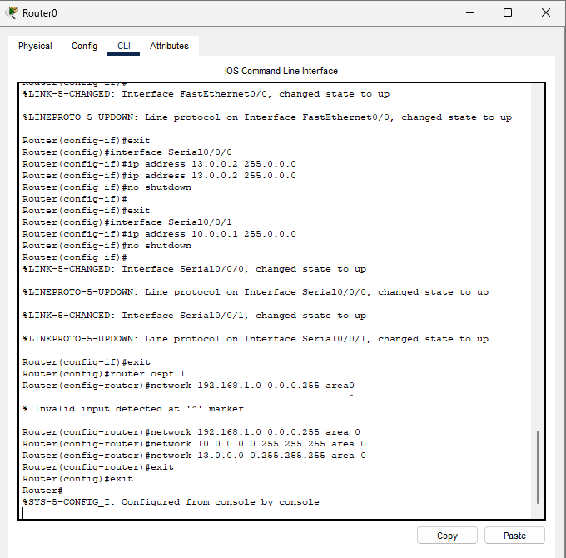

* OSPF Route of ROUTER 1

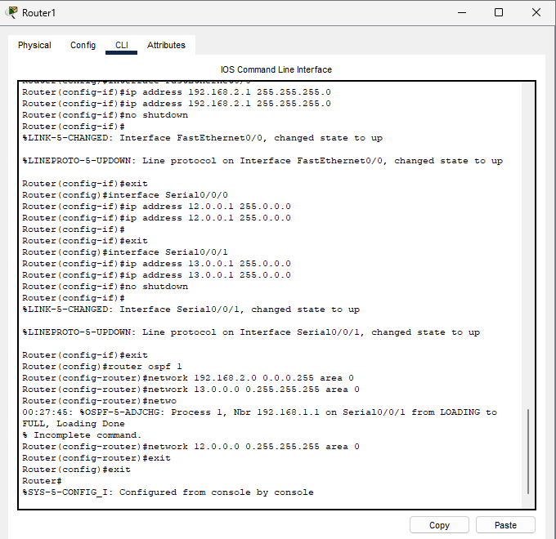

* OSPF Route of ROUTER 2

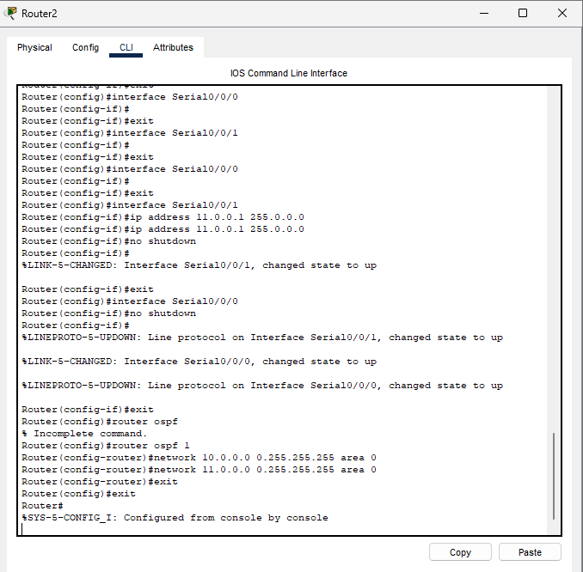

* OSPF Route of ROUTER 3

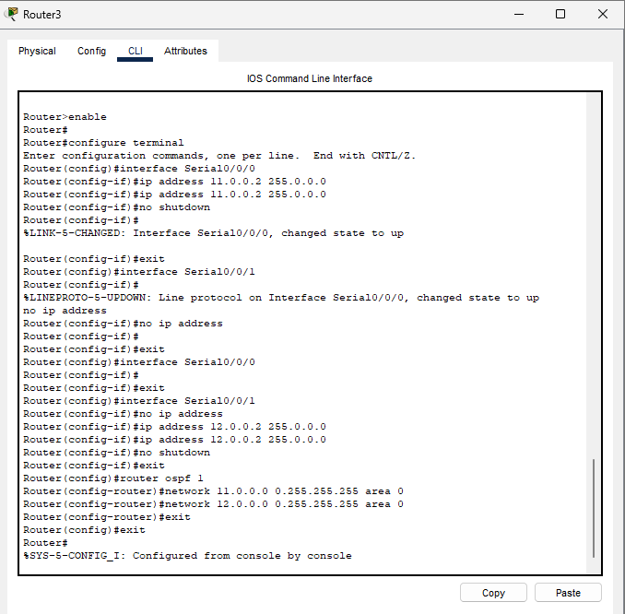

**Step 6:** Verify the network by pinging the IP address of any PC. First, click on PC1 then Go to the command prompt then type ping <IP address of targeted node>As we can see in the below image we are getting replies which means the connection is working very fine.

Pinging 192.168.2.2 from PC0.

